|  |  |
| --- | --- |
| **What were men and women’s experiences of World War I?** | |
| Content Standards | 10.5 Students analyze the causes and course of the First World War. 4. Understand the nature of the war and its human costs (military and civilian) on all sides of the conflict, including how colonial peoples contributed to the war effort. |
| Common Core State Standards | **RH 9-10 1.** Cite specific textual evidence to support analysis of primary and secondary sources, attending to such features as the date and origin of the information.  **RH 9-10 2.** Determine the central ideas or information of a primary or secondary source; provide an accurate summary of how key events or ideas develop over the course of the text.  **RH 9-10 3.** Identify key steps in a text’s description of a process related to history/social studies…  **RH 9-10 4.** Determine the meaning of words and phrases as they are used in a text, including vocabulary describing political, social, or economic aspects of history/social science.  **RH 9-10 5.** Analyze how a text uses structure to emphasize key points or advance an explanation or analysis  **RH 9-10 9.** Compare and contrast treatments of the same topic in several primary and secondary sources.  **WH 9-10 1.** Write arguments focused on *discipline-specific content*  **WH 9-10 2.** Write informative/explanatory texts, including the  narration of historical events, scientific  procedures/experiments, or technical processes.  **WH 9-10 4.** Produce clear and coherent writing in which the  development and organization, and style are appropriate to the  task, purpose, and audience. |

The lesson is below the key.

In conjunction with the lesson, teachers may want to share the clip on Olusoga and his research on Africa and colonial soldier’s role in World War I, which can be found at

<http://www.bbc.co.uk/programmes/b04dh242/clips>

**Key**

1. Paul pulls on his gas mask, helps his fellow soldier put his on, then breathes through the gas mask very slowly to try it out.

1. Paul and the soldiers are very terrified of the gas because of the effects of it on the soldiers. Often the gas caused coughing fits and incapacitated the soldiers. In addition, it could cause permanent damage, even death. It was used as a weapon to terrorize soldiers on the opposing side. For more information, visit this link:

http://www.historylearningsite.co.uk/world-war-one/the-western-front-in-world-war-one/poison-gas-and-world-war-one/

1. Summaries will vary.
2. Soldiers diet at the battlefront varied. At times, the rolling dining carts could bring hot food to the soldiers, but often this was not possible and then the soldiers ate cold, food from tins.
3. Everyday life for the soldier at the front lines was often boring. The soldiers were in the trenches all day and followed a specific routine. Soldiers would fire across “no man’s land” to the other side before breakfast, take a break by preparing their weapons and trenches for more battle, and then at the end of the day guard or prepare for attack.
4. The British army prepared the postcards to allow soldiers to easily communicate with their family and friends at home. They contain little opportunity for personal communication, rather soldiers just check boxes. These are purposefully vague so soldiers’ lives at the battlefront remained mysterious and hidden to the people at home. They could not communicate the horrible conditions at the front.
5. Answers will vary, but they may want to highlight that there is no way for the soldiers to communicate any personal information so the government was trying to censor the soldiers.
6. Answers will vary
7. Answers will vary
8. Like Remarque war is not glorified in Owen’s poem. War brings pain, exhaustion, and death in both literary accounts. Both recount the shelling and gas and the terrible effects of each. Both the poem and the novel suggest that the soldiers were lied to by society and their teachers that war is not something to honor, but rather something to avoid all together. Owen uses language differently than Remarque, with an emphasis on the bodily harm that war does to the soldiers who are represented as oppressed and do not seem like young men, rather sick old men.
9. Answers will vary
10. Answers will vary
11. This letter is similar to Owens and Remarque describing the mass death of the soldiers of the war. He is different in that he mentions the feeling of cold and experiences of terrible smells at the front. In addition, he discusses what life must be like at home as a result of the death of so many Indian soldiers.
12. Because of the massive amount of casualties of British soldiers, Maoris were allowed to serve as laborers on the front lines.
13. They did manual labor, “dug and repaired trenches, built roads and undertook forestry work.”
14. The Maoris died at the front lines, like white and Indian soldiers, but they were not equipped with weapons to defend themselves, rather they worked to support the war effort through manual labor.
15. Answers will vary
16. The French recruited African soldiers much like the raided for slaves, by imprisoning them and requiring them to serve.
17. Remarque suggests that the German soldiers were recruited through mental and social pressure by the state, adults, and people in authority who used patriotic sentiment to persuade German boys and youth to enlist. This is different than these African soldiers who were forced to be a part of the military.
18. African soldiers were recruited by the French to save French lives and stand in for white soldiers during the worst part of the battles, as “cannon fodder.”
19. Answers will vary.
20. Africans were used for labor at the front.
21. British attitudes created the context that allowed only whites and Indians to serve as soldiers. Blacks were seen as inferior so could only serve as menial labor. They were also segregated from white soldiers and the French population.
22. Answers will vary
23. Answers will vary
24. Women served in roles that were in the public, filling roles and occupations that were normally considered men’s work.
25. Women could argue that since they filled public roles during war, they were responsible and capable of earning the vote after the war.
26. The nurses care for the soldiers. They do things like make the beds and change their clothes, but also care for them mentally by bringing them happiness.
27. Paul describes the nuns as professional and capable and the volunteers as timid and not very good at providing actual assistance to the soldiers.
28. Women worked outside the home because they needed income and because the state needed labor and most men were at the front.
29. The article suggests that work was negative for women because they were harassed and treated unfairly by their employers and paid much less for the same work as men.
30. Farmerette work looks like a lot of fun with the image and the cheer. The women were working together to support the war effort.
31. Being able to do patriotic work to support the war allowed women to claim that they were responsible citizens who deserved the vote.

**Additional References and Resources**

If you are interested in sharing with your students about the Christmas truce, there is a nice article about how it has been remembered in Time magazine:

<http://time.com/3643889/christmas-truce-1914/>

|  |
| --- |
| **Inquiry Question: What were men and women’s experiences of World War I?** |

**Introduction**

While the battles of World War I primarily took part in Europe, the effects of the war reached around the world. Men, women, and children experienced the consequences of the conflict. Men volunteered or were conscripted into the military to fight on the battlefields. The success of each side’s military required not only manpower, but weapons, food, and supplies. These materials had to be produced at home or in the colonies, which required women to take on duties that were not considered feminine roles, such as working in factories and farming. Because entire societies were mobilized to support the war effort, World War I is considered a total war.

During and after the war, European soldiers, like Erich Maria Remarque, wrote about their experiences on the battle lines as well as their feelings upon their return home. These letters, poems, and writings are an important way for us to understand the perspectives of ordinary soldiers who participated in trench warfare. With the hundredth anniversary of World War I, historians have tried to gain a fuller, more nuanced, picture of the experiences of soldiers and civilians during this war. For these reasons, historians have started to consider the role of women and of colonial soldiers in the war effort. Through a study of photos, first-hand accounts such as journals and letters, and by rereading official military communications, historians have begun to uncover a more complicated story of World War I. This new scholarship shows the ways that race, class, and gender shaped the experience of war. We will consider these experiences both on the front lines and at home to answer the question: **What were men and women’s experiences of World War I?**

|  |  |
| --- | --- |
| Photo postcard of German soldiers in 1916.  Found in the Bowman Gray Collection at t the University of North Carolina Chapel Hill.   |  | | --- | |  | |

**Part 1: European Soldiers’ Experiences of War**

**Erich Maria Remarque*, All Quiet on the Western Front*, 1928.**

The narrator in *All Quiet on the Western Front,* Paul Baümer, describes an attack on his battallion.

|  |  |
| --- | --- |
| I grab for my gas-mask. Some distance from me there lies someone. I think of nothing but this: That fellow there must know: Gaaas--Gaaas—  I call, I lean toward him, I swipe at him with the satchel, he doesn't see--once again, again--he merely ducks--it's a recruit--I look at Kat desperately, he has his mask on--I pull out mine, too, my helmet falls to one side, it slips over my face, I reach the man, his satchel is on the side nearest me, I seize the mask, pull it over his head, he understands, I let go and with a jump drop into the shell-hole.  The dull thud of the gas-shells mingles with the crashes of the high explosives. A bell sounds between the explosions, gongs, and metal clappers warning everyone--Gas--Gas--Gaas.  Someone plumps down behind me, another. I wipe the goggles of my mask clear of the moist breath. It is Kat, Kropp, and someone else. All four of us lie there in heavy, watchful suspense and breathe as lightly as possible.  These first minutes with the mask decide between life and death: is it air-tight? I remember the awful sights in the hospital: the gas patients who in day-long suffocation cough up their burnt lungs in clots.  Cautiously, the mouth applied to the valve, I breathe. The gas still creeps over the ground and sinks into all hollows. Like a big, soft jellyfish it floats into our shell-hole and lolls there obscenely.  I nudge Kat, it is better to crawl out and lie on top than to stay where the gas collects most. But we don't get as far as that; a second bombardment begins. It is no longer as though shells roared; it is the earth itself raging.  Pages 68-69 | **satchel—**a bag or backpack  **recruit—**a man new to the military  **suffocation—**unable to breathe  **lolls—**moving in a slow, lazy way |

1. What is Paul’s response to the gas attack?
2. Why are the soldiers so fearful of the gas?

**Dinner Rations, 1916 at the Battle of Somme**

|  |
| --- |
| Hot food was not supplied to front line soldiers until late 1915, but even then kitchens could not always get close enough to provide a hot meal for all soldiers. Troops in the front line often endured a repetitive diet of cold tinned food.  A unit would spend a few days in the front line, followed by periods in reserve and rest. |

1. Summarize what is going on in this photo in 2-3 sentences.
2. Given the photo and the text underneath it, what can you claim about soldiers’ diet at the battlefront?

**A typical day on the frontline**

|  |
| --- |
| from the BBC, <http://www.bbc.co.uk/guides/z3kgjxs#ztbs4wx>  “Stand to” means that the soldiers climbed to the top of the trench to guard or fire into “No Man’s Land  Morning Hate was when soldiers fired at the opposing side at dawn |

1. After viewing the two sources above, describe what life was like for a soldier stationed at the front in World War I. What are some words that could describe everyday life. Use evidence from the sources to support your description.

**Field Service Postcard**

“Field Service Postcards” were issued by the British Army in November 1914. Known as “Quick Firers,” these postcards were mass-produced in the millions and given to infantry soldiers who would send them to family and friends as evidence of being alive and safe.

|  |  |
| --- | --- |
|  | This letter was sent to by Wilfred Owen, an officer and poet, to his mother. By previous agreement, Owen’s double strikeout of “I am being sent down to base” indicates that he was headed to the front lines of the Western Front. By late 1918, Owen feared that his mother might misread this secret system of communication and worry unduly: on October 29, 1918 he wrote to Susan Owen, “I don’t want to send Field Cards in case you suppose they mean in the Line. In future . . . a F. Card will be no proof that I am actually there.” He assured his mother he was not headed toward battle. A few short hours after writing the letter, his battalion was moved to the front line of the Sambre-Oise Canal, where nine days later he was killed by a German sniper. Owen’s parents received the news of his death on November 11, 1918, the day of the cease-fire. |

**Field Service Postcard**

**Questions**

1. How does the British government expect its soldiers to communicate with their friends and family at home? Does this allow for them to share what their lives were like at the battlefront? Explain your answer using evidence from the source.
2. Why do you think that the government used the field service post-card as a form of communication?

**Wilfred Owen, “Dulce et decorum est,” written between October 1917 and March, 1918**

This poem is one of the most famous poems of World War I written by a soldier on the front lines. Watch the reading of the poem on video accompanied by film footage from the Battle of the Somme.

DULCE ET DECORUM EST - the first words of a Latin saying. The words were widely understood and often quoted at the start of the First World War. They mean "It is sweet and right." The full saying ends the poem: Dulce et decorum est pro patria mori - it is sweet and right to die for your country. In other words, it is a wonderful and great honour to fight and die for your country.

|  |  |
| --- | --- |
| **Wilfred Owen, “Dulce et decorum est,”** <https://www.youtube.com/watch?v=d7MuMnss4Rw> | |
| 8**.** What are some words that stick out, or resonate, from the poem? |  |
| 9. What feeling do you get from hearing this poem and viewing the film footage? |  |
| 10. How does the poem compare and contrast to Remarque’s descriptions of war? |  |
| 11. Reread the Field Service postcard above, Owen wrote both it and the poem, “Dulce et decorum est.” Using these two sources, make a claim about what life was like for European soldiers at the Western front. |  |

**Part 2: Colonial Subjects Experiences of War**

The British and French governments realized that by having more men on the battlefield, they would have an advantage over the German and other Central Powers, armies. For this reason, they recruited and conscripted colonial soldiers and workers from their empire. Over four million non-white colonial men were mobilized for the war effort. This decision to include colonial soldiers was debated by both governments. Historian Santanu Das explains the issues of using non-white, colonial soldiers, “If a ‘coloured’ man were trained to raise arms against another European, what guarantee was there, so the racial thinking went, that he would not one day attack his own white master? However, after heavy casualties were suffered by the British Expeditionary Force in August 1914, two Indian divisions were diverted to France. Among the colonial non-white troops of the British empire, only Indians were allowed to fight in Europe. This was predominantly due to racial categorisation in British military policy.” While the British fielded only Indian soldiers, the French drew upon their African colonies to conscript labor and soldiers. As you read the sources below consider how the colonial soldiers experiences were similar and different to the European soldiers experiences you analyzed above.

**“Letter home from Indian soldier that was rejected for mailing by the Censor in Reports of the Censor of Indian Mails in France,” Report 5-13 January 1915.**

|  |  |
| --- | --- |
| In this sinful country it rains very much and also snows and many men have been frostbitten. Some of their hands and feet cannot be stretched out and those who stand cannot sit down again. Some have died like this and some have been killed by bullets. In a few days you will hear that in our country only women will be left. All the men will be finished here. Thousands and hundreds of thousands of soldiers have been killed. If you go onto the battlefield you will see corpses piled upon corpses so that there is no place to put hand or foot. Men have died from the stench. No-one has any hope of survival. The whole world is being brought to destruction. I cannot describe the war because 30,000 men have been destroyed and 20,000 more will be destroyed. | **corpse**—dead body  **stench**—smell |

12. Summarize the description of the battlefield in the letter.

13. How is this similar and different to the ways that Owen and Remarque describe the frontlines?

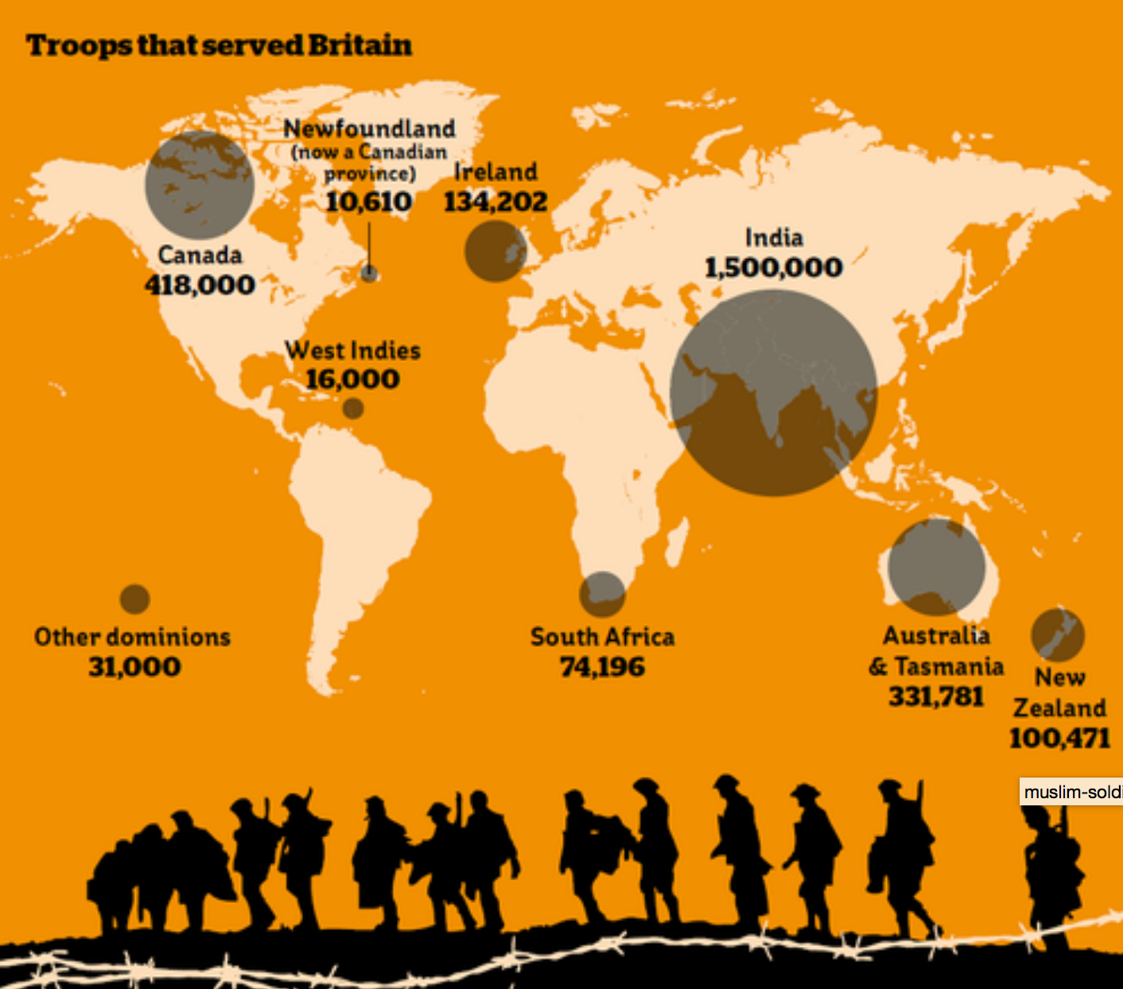

Found at: <https://www.indy100.com/article/map-the-troops-from-around-the-world-that-served-britain-in-wwi--xJIQVBP_fl>

**Ian Proctor, How Maoris battled to fight together in the First World War**

Proctor is an archivist from Britain’s Imperial War Museum and writes of the Maori’s role in World War I. The Maori’s are the indigenous, or native people, or New Zealand. New Zealand was a part of the British Empire and sent both white and native soldiers to battle on the Western front.

|  |  |
| --- | --- |
| When King George V declared war on Germany in August 1914, he did so for Britain and his dominions and colonies throughout the Empire. Across New Zealand thousands of men volunteered in support of their mother-country. Between 1914 and 1918 more than 120,000 New Zealanders – nearly 20% of the country’s eligible manpower – served overseas with the New Zealand Expeditionary Force, the Royal Navy or units of the British Army.  Imperial and colonial governments initially sought to prevent Maoris, the indigenous people of New Zealand, from participating in the First World War. While a small number of Maoris volunteered to serve with regional infantry units, Britain and New Zealand continued a pre-war policy opposing the formation of an all-Maori unit to fight in a war against Europeans. Yet by 1918 over 2,500 Maori soldiers had served overseas, the majority in what became known as the Maori Pioneer Battalion…  Any continuing reluctance to using Maori soldiers was soon overcome by the significant number of casualties from the campaign…  The pioneers [Maori soldiers] were sent to France in April 1916 where they dug and repaired trenches, built roads and undertook forestry work. They were the first New Zealanders at the Somme battlefield, arriving in August to dig an 8km trench leading to the front line and prepare the ground for the arrival of the remainder of the New Zealand Division.  By June 1917, the battalion was in Belgium for the Battle of Messines. The pioneers’ hard, physical work was often undertaken under artillery fire and within range of snipers at the cost of many men…  The battalion remained on the Western Front until the end of the war. Of the 2227 men who had served in the unit since 1914, nearly half became casualties – with 336 dead and a further 734 wounded. Thirty eight members of the contingent and pioneer regiments received the Military Medal while four received the Distinguished Conduct Medal and nine the Military Cross…  http://www.iwm.org.uk/history/how-maoris-battled-to-fight-together-in-the-first-world-war | **Dominions—**had its own government, but was still part of the British empire  **Colony—**the government of Britain directly controlled the area, often the difference has to do with the racial make-up of the areas under control, with Canada, Australia, and New Zealand as dominions and largely populated by whites of European descent.  **reluctance—**unwillingness, does not want to do something  **casualties—**deaths and injuries |

14. Why did the British government allow the Maori’s to go to Europe to support the war?

15. What did the Maori Pioneers do on the Western Front?

16. How was the Maori’s experience similar and different to the European soldiers’ experiences?

**Photo of the Tirailleurs Sénégalais**

The Tirailleurs Sénégalais were a professional army from France’s African colonies, including Senegal. The term tirailleur means sharpshooter. They had been fighting in Africa on behalf of France since 1857. However, with the major casualties of European soldiers the recruitment of African soldiers to fight in Europe began and even increased as the war went on. On the Western Front, these men served with distinction and were commended for their bravery.

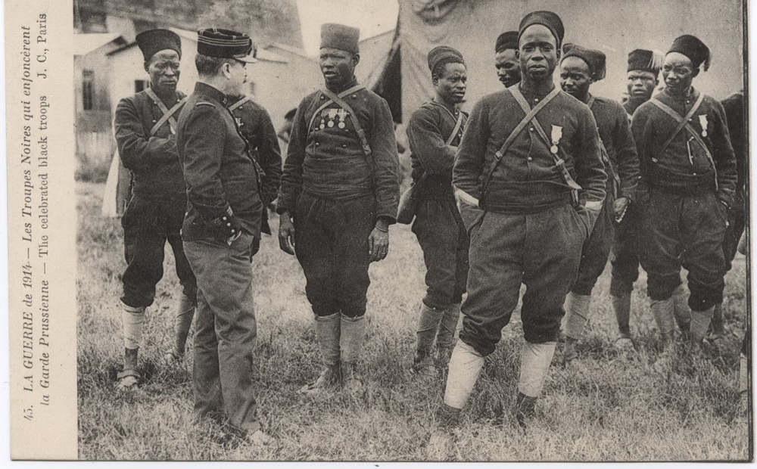

Found at: <http://www.totem-world.com/faut-il-rappeler-ce-que-la-france-doit-a-ses-tirailleurs-blackm.html>

1. Summarize what is going on in this photo in 2-3 sentences.

**Excerpt from *The World’s War: Forgotten Soldiers of Empire*, David Olusoga p. 164,165, and 195.**

Olusoga’s book examines the role of colonial soldiers in World War I. He is interested in seeing how these men experience the war and shining a light on the explicitly racist policies of the European imperial states fighting on both sides of the war. As you read this text, consider how the French government recruited and employed African soldiers, like the Tirailleurs Sénégalais.

|  |  |
| --- | --- |
| ...French colonialists had justified their take-over of much of West Africa--to themselves and to Africans-- on the grounds that the French *mission civilisatrice* would bring an end to the slave trade in that part of the continent.  Yet the truth is that during the First World War African men were seized from their villages, held prisoner and marched in chains, and were then shipped to the battlefields of France to fight in the name of liberty and civilization. The French even had a phrase for enforced recruitment of Africans: *limpot du sang,* ‘the tax in blood’...  [A French military officer wrote]  *My aim to seek the use of the Senegalese...in order to spare the blood of French servicemen, France having already paid a heavy tribute during this war. It is essential to try by all means possible to diminish their future losses through the enhanced use of our brave Senegalese...The Senegalese have been recruited to replace the French, to be used as cannon fodder to spare the whites. It is essential then to use them in an intensive fashion…* | **mission civilisatrice—**civilizing mission, part of the imperial powers justifications for control of Africa was that they would bring progress and modernity to Africans  **cannon fodder—**soldiers used in war and sent to die |

1. How did the French “recruit” African soldiers?
2. How is this recruitment different than the persuasion described by Remarque in Lesson 1?
3. What was the African soldier’s role in the military according to the French officer?

**Photo of men from the South African Labor Corps**

As mentioned above, the British government only used Indians as soldiers. Other non-whites were used at the Western Front for labor. South Africans made up the labor corps of which 21,000 worked doing menial tasks and were housed in segregated units. Koos Matli a member of the South African Labor Corps recounts, “There we had a hard time, because nearly every evening we were attacked by the enemy planes and we had nothing to defend ourselves with. This camp was twice in flames during enemy attacks. We formed a committee, and after some discussions agreed to send a letter to England. We wrote the letter and explained our condition. We addressed the letter to His Majesty King George V. We gave our letter to one of the soldiers to post for us, since we were not allowed to go outside the Camp.”

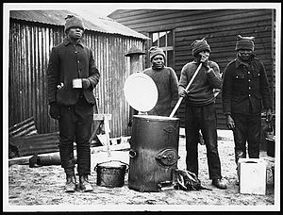

Image found at:https://en.wikipedia.org/wiki/South_African_Native_Labour_Corps

**Photo of men from the South African Labor Corps**

**Questions**

1. Summarize what is going on in this photo in 2-3 sentences.
2. How did the British employ colonial Africans on the Western Front? Use the text and photo as evidence for your response.
3. How did British attitudes create a racial hierarchy on the Western Front?

**Part 3: Women and children’s experiences on the Homefront**

While men largely made up the bulk of the labor on the battlefront, women and children were greatly affected by the war. We will read and view sources to consider how women and children’s lives were changed by the death and destruction of the war.

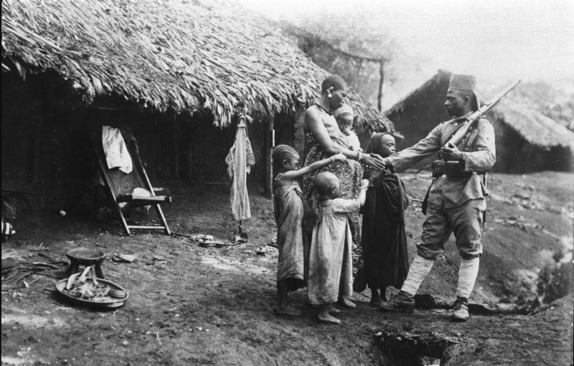

*A soldier says goodbye to his family as he departs for the war.  German East Africa*, *c. 1914-1918*

**Photograph of woman worker at British factory**

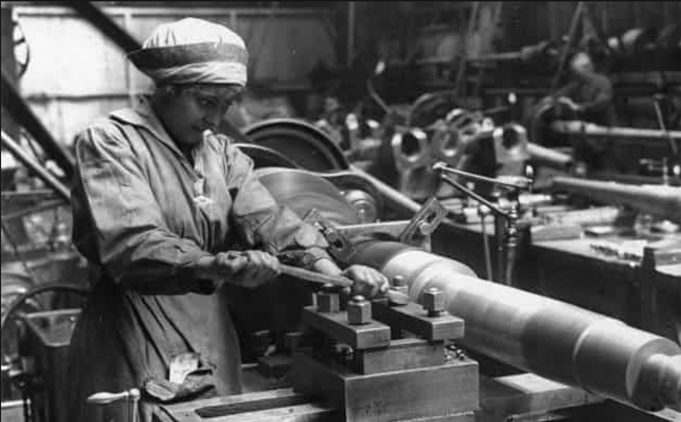

1. Summarize what is going on in this photo in 2-3 sentences.

**Photograph of Women Police Officers in Britain**

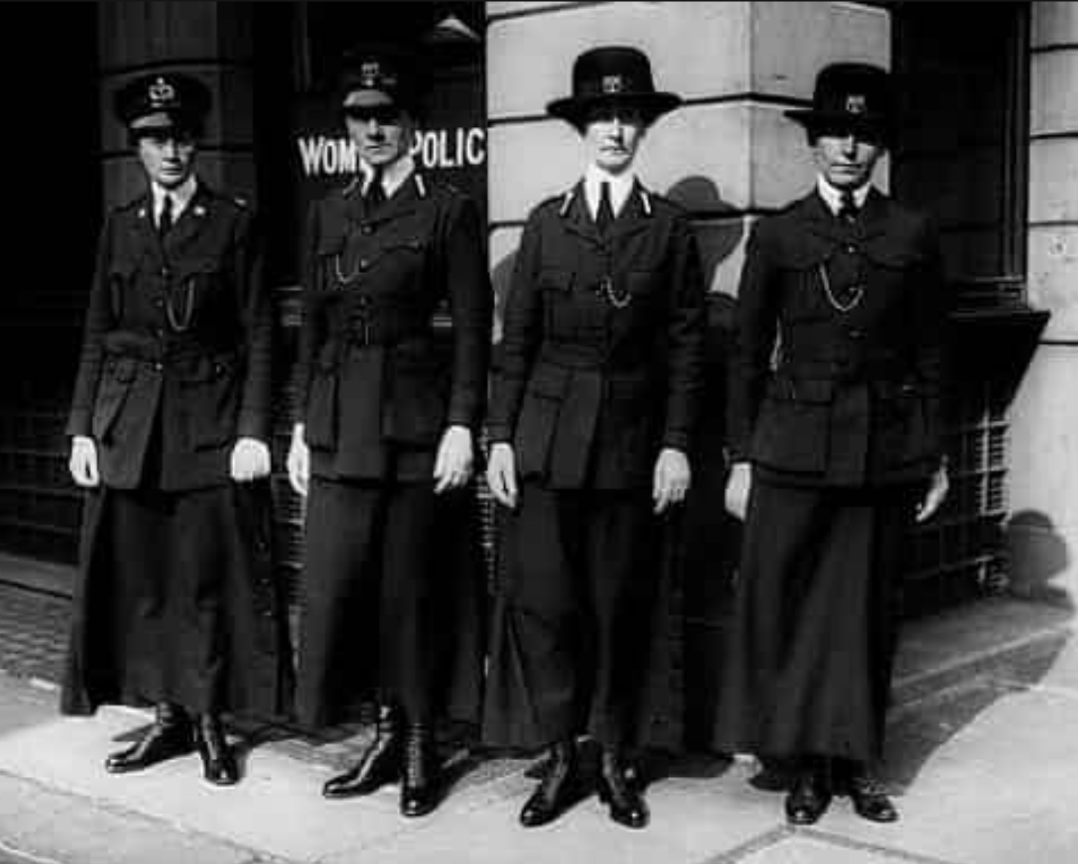

Both photos found at: <https://www.theguardian.com/world/gallery/2008/nov/11/first-world-war-women>

1. Summarize what is going on in this photo in 2-3 sentences.

**Photograph of Women Police Officers in Britain**

**Questions**

1. After viewing both of these photos, what can you say about women’s new roles during wartime?
2. After the war, women advocated for the right to vote in Britain, how might their work during war have given their argument extra weight?

**Erich Maria Remarque*, All Quiet on the Western Front*, 1928.**

The narrator in *All Quiet on the Western Front,* Paul Baümer, describes his recovery at a hospital in Germany, away from the battlefront. In this excerpt he compares women nurses, both volunteers and nuns, and the assistance they give him and his fellow soldiers.

|  |  |
| --- | --- |
| Sometimes there are red-cross voluntary aid sisters. They are pleasant, but often rather unskilled. They frequently give us pain when re-making our beds, and then are so frightened that they hurt us still more.  The nuns are more reliable. They know how they must take hold of us, but we would be better pleased if they were somewhat more cheerful. A few of them have real spirit, they are superb. There is no one but would do anything for Sister Libertine, this marvelous sister, who spreads good cheer through the whole wing even when she can only be seen in the distance. And there are others like her. We would go through fire for her. A man cannot really complain, here he is treated by the nuns exactly like a civilian. And just to think of a garrison hospital gives one the creeps.  Page 256 | **garrison— military** |

1. What work do the women nurses do for Paul and the other soldiers?
2. How does he compare and contrast the volunteers and the nuns?

**Herwig, H. The First World War: Germany and Austria-Hungary 1914-1918, Bloomsbury Academic, 1996.**

|  |  |
| --- | --- |
| With mass conscription and subsequent call-ups year after year, employers were faced with the problem of filling the positions of millions of men. They opened up jobs to the remaining population on the German home front and turned to two social groups, each of which experienced the workplace differently; women and youths...  The loss of a husband or father meant a loss of income, and families struggled to survive on government hand-outs. …  It was these women upon whom Germany relied to cover the labour shortage, creating an income for families and to stabilise employment. While it seems such women played a major part in the German economy, there were some very serious disadvantages to working.  Women increasingly found themselves being treated as inferior to the men they worked alongside and those away fighting. Many employers made it clear that once the war ended their jobs would not be safe and would be re-opened to the men that had left them behind…  Many were not paid half the amount their male counterparts earned. They were required to work long hours too, which meant that not only could they hardly afford basic necessities, but also that they had far less time to spend with their children…  <http://www.centenarynews.com/article?id=717> | **conscription—**forced military service  **labour shortage**—lack of workers in the economy  **inferior**—less important than |

1. What were the reasons the article gives for women working outside the home?
2. According to the article, was working in the factories positive or negative for German women? Use evidence from the article to support your claim.

**Photograph of Farmerettes from the Women’s Land Army**

|  |  |
| --- | --- |
| Found at: http://www.smithsonianmag.com/history/before-rosie-the-riveter-farmerettes-went-to-work- | Women across Califronia signed up to pick fruit and vegetables and work on farms to support the war effort with the Women’s Land Army. Their cheer was:  *Don’t be a slacker*  *Be a picker or a packer*  *WLA, Rah, rah, rah!* |

1. How was farmerette’s work represented in this image and the cheer?
2. After the war, women advocated for the right to vote in the United States, how might their work during war have given their argument extra weight?

**Final Activity: What were men and women’s experiences of World War I?**

Men and women sacrificed their labor, time, and often their health and lives to give to the war effort. However, as you have seen the types of activities that these groups engaged in were different. Write an essay that compares the work done my European soldiers, colonial men, and women during the war in order to answer the question:

**What were men and women’s experiences of World War I?**

Use the chart below to take notes from the sources above. The notes will be helpful for the final essay below.

|  |  |  |  |
| --- | --- | --- | --- |
|  | What types of **work** did they do for the war? | How did this **work** support the war effort? | Summarize the **work** experience for this group. |
| European soldiers |  |  |  |
| Colonial men |  |  |  |
| Western women |  |  |  |

**How was work during war time similar and different for men and women?**

|  |  |
| --- | --- |
| Topic Sentence/ Claim: | Men and women worked for the war doing  however, his work often differed because |
| Supporting Evidence of similarity | Evidence 1 (European soldiers)  Evidence 2 (Colonial men)  Evidence 3 (Women) |
| Analysis: Explain why this work was similar and the effects it had on the war effort. |  |
| Supporting evidence of difference | Evidence 1 (European soldiers)  Evidence 2 (Colonial men)  Evidence 3 (Women) |
| Analysis: Explain why this work was different and the effects it had on the war effort. |  |
| Conclusion  How do race and gender play a role in the way people experienced the war? |  |

**Extension Activity: How did the effects of the war shape the way people saw the world and their place in it?**

Erich Maria Remarque’s novel, *All Quiet on the Western Front*, was one of many cultural productions—such as literature, painting, and architecture—created after the war to commemorate the war and its effects on society. The devastation of the war on an entire generation of men (European and colonial) profoundly shaped the way the survivors of war imagined the world. While the war can be considered the first **modern** war because of the scope (linking the battlefront and homefront), the technology (weapons), and communication (propaganda), the cultural effects were also the beginning of the modern art movement. Remarque’s novel is an example of this movement that was critical of the war. He writes about how his generation was disillusioned as a result of the bloodshed they experienced,

“All I do know is that this business about professions and studies and salaries and so on—it makes me sick. It is and always was disgusting….all at once everything seems to me confused and hopeless…it’s the same for everyone; not only fur us here, but everywhere, for everyone who is of our age; to some more, an to others less. It is the common fate of our generation….We are not youth any longer. We don’t want to take the world by storm. We are fleeing. We fly from ourselves. From our life. We were eighteen and had begun to love life and the world; and we had to shoot it to pieces. The first bomb, the first explosion, burst in our hearts. We are cut off from activity, from striving, from progress. We believe in such things no longer, we believe in war.” (pages 87-88).

|  |  |
| --- | --- |
| The futility of war and the reaction to it was very pronounced in the post-war culture and can be exemplified by the **Dada** art movement. The name Dada was supposed to be nonsense. One story of the naming of Dada goes, that the name was chosen randomly by stabbing a dictionary with a knife. Dadaism questioned existing society and revolted against rationality. “The beginnings of Dada,” poet Tristan Tzara, one of the founders of Dadaism recalled, “were not the beginnings of art, but of disgust.” There was no one type of Dadaist art, often they used uncommon materials, such as everyday items, and welded and glued objects together. Dadaist poetry consisted of words often randomly selected and put together in another order. Because of the abstract nature of Dadaist art, it can be called one of the first modern art forms. | Richard Boix. Da-da (New York Dada Group). 1921. |

Now you will have a chance to make Dadaist inspired art. There are directions below to make a Dadaist poem. Make one, three, or none—the point is that there is not point ☺

To make a Dadaist poem (using the method of Tristan Tzara):

* Take a newspaper.
* Take a pair of scissors.
* Choose an article as long as you are planning to make your poem. [It is best to use one or two paragraphs.]
* Cut out the article.
* Then cut out each of the words that make up this article and put them in a bag.
* Shake it gently.
* Then take out the scraps one after the other in the order in which they left the bag.
* Copy conscientiously.
* The poem will be like you.
* And here you are a writer, infinitely original and endowed with a sensibility that is charming though beyond the understanding of the vulgar.

-Tristan Tzara